Tree in Data Structure



A decision tree is a very specific type of probability tree that enables you to make a decision about some kind of process. It is used to break down complex problems or branches. Each branch of the decision tree could be a possible outcome.

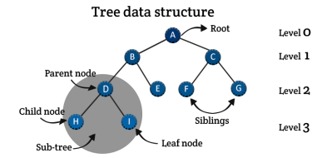

www.aiquest.org

Decision Tree Algorithm

The **decision tree** is a very specific type of probability tree that enables you to plan about some kind of process. It is used to break down complex problems or branches. Each branch of the decision tree could be a possible outcome.

▪ Supervised

▪ Classification/Regression

▪ Information Gain (IG)

▪ Entropy

▪ Gini Index

www.aiquest.org

Problem Statement:

Class

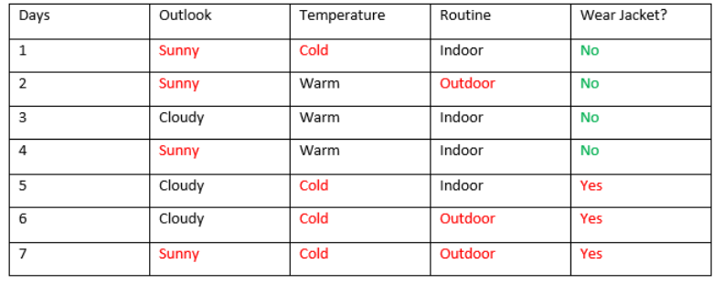www.aiquest.org

Solving Logarithms: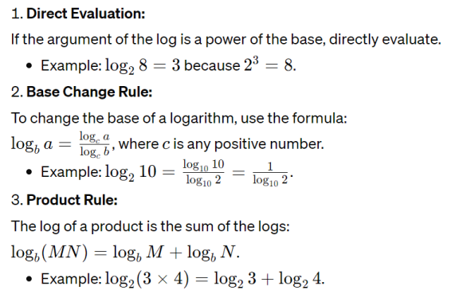www.aiquest.org

Solving Logarithms: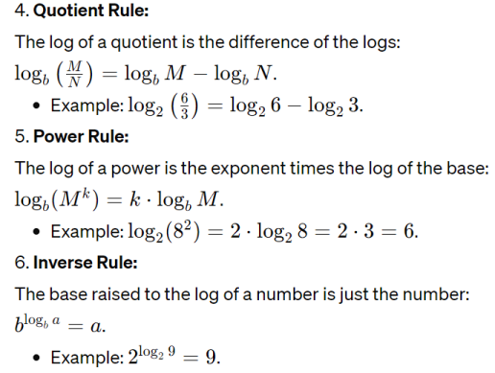

www.aiquest.org

| **Wear Jacket?**  No 4 times | |
| --- | --- |
| Yes | 3 times |

Relevant EquationsEntropy Before Partition:

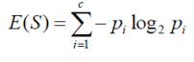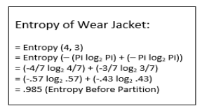



E(Y) = Entropy Before Partition

E(Y|X) = Entropy After Partition

Target, E(Y) >> E(Y|X)

www.aiquest.org

Explanation:

www.aiquest.org

Solving DT Classifier Algorithm

www.aiquest.org



Solving DT Classifier Algorithm

www.aiquest.org

Solving DT Classifier Algorithm

www.aiquest.org

Solving DT Classifier Algorithm

www.aiquest.org

Solving DT Classifier Algorithm

Root Node

(Temperature)

Cold

Yes(3), No(1) (1,5,6,7)



Warm

Yes(0), No(3)

(2,3,4)

www.aiquest.org

Root Node

(Temperature)

Cold

Yes(3), No(1)

(1,5,6,7)

Solving DT Classifier Algorithm

Warm 

Yes(0), No(3)

(2,3,4)

www.aiquest.org

Solving DT Classifier Algorithm

www.aiquest.org

Solving DT Classifier Algorithmwww.aiquest.org

Solving DT Classifier Algorithmwww.aiquest.org

Solving DT Classifier Algorithm

Temperature

Cold

Warm

Indoor

Routine

Sunny, Cold , Indoor= ??

www.aiquest.org

(No)

Outdoor

(Yes)

Solving DT Classifier AlgorithmOutlook 

no yes Sunny Cloudy

www.aiquest.org

Solving DT Classifier Algorithm

Temperature

Cold

Warm

Indoor

Outlook

Sunny (No)

Routine

Cloudy (Yes)

Outdoor (Yes)

(No)

Sunny, Cold , Indoor= ??

www.aiquest.org